Final 2018 second semester

- Define DSS and BI. Explain BI Architecture component. ^{(Chapter 1)}

- DSS - interactive computer-based systems, which help decision makers utilize data and models to solve unstructured problems.

- BI - is an umbrella term that combines architectures, tools, databases, analytical tools, applications, and methodologies

BI system has four major components:

  - a data warehouse, with its source data
  - business analytics, a collection of tools for manipulating, mining, and analyzing the data in the data warehouse
  - business performance management (BPM) for monitoring and analyzing performance
  - a user interface (e.g., dashboard)

- What is Hadoop? how it’s work and what its technical component? ^{(Chapter 13)}

Hadoop is an open source framework for storing and analyzing massive amounts of distributed, unstructured data.

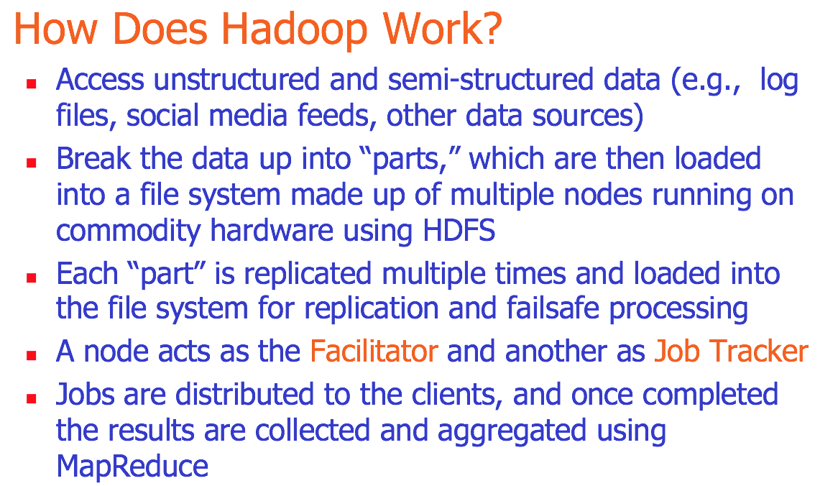

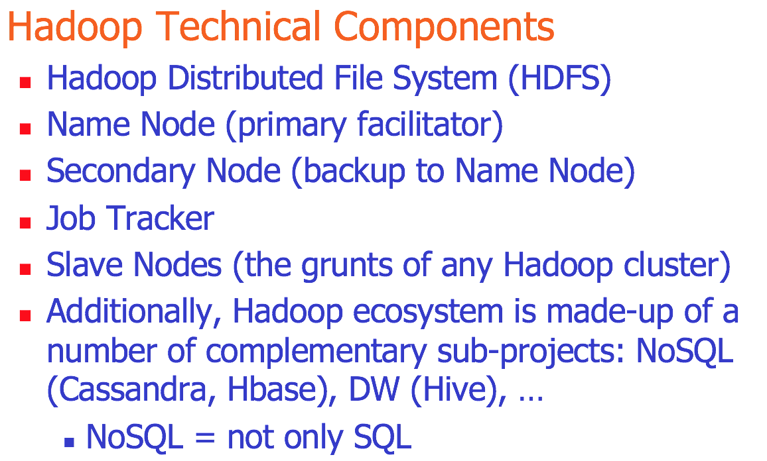

- List 5 types of specialized charts and graphs. ^{(Chapter 4)}

- Histogram
- Gantt Chart
- PERT Chart
- Geographic Map
- Bullet Graph
- Heat Map / Tree Map
- Highlight Table

- List 3 terms of how decision makers think and react to problem. And list 3 of decision management styles. ^{(Chapter 2)}

  - The way they perceive the problem.
  - Their cognitive response.
  - how values and beliefs vary from individual to individual and from situation to situation.

Decision-making styles
  - Heuristic versus Analytic
  - Autocratic versus Democratic
  - Consultative (with individuals or groups)

- Give 2 advantages of working in group and 2 disadvantages. ^{(Chapter 12)}

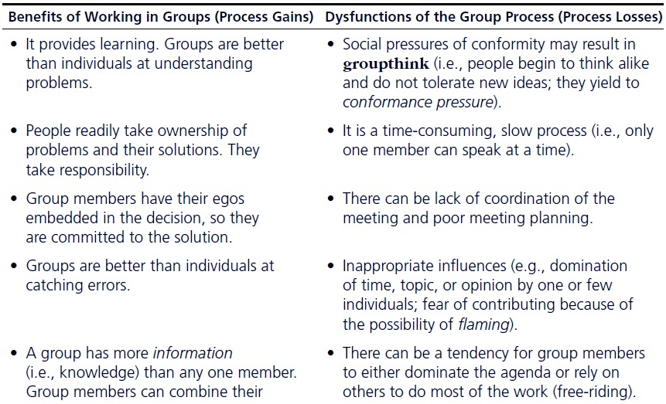

- Define: simulation and mention its benefits. ^{(Chapter 10)}

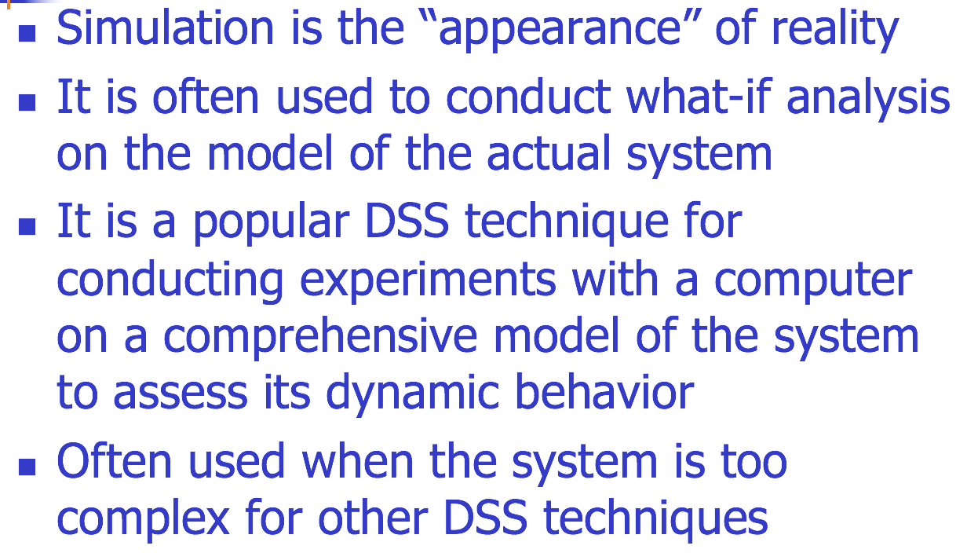
Advantages of simulation:

- The theory is fairly straightforward.
- Great deal of time compression
- Experiment with different alternatives
- The model reflects manager’s perspective
- Can handle wide variety of problem types
- Can include the real complexities of problems
- Produces important performance measures
- Often it is the only DSS modeling tool for non-structured problems

- Define Heuristic and when to use it. ^{(chapter 10)}

Heuristics are the informal, judgmental knowledge of an application area that constitute the rules of good judgment in the field.

When to Use Heuristics?
- Inexact or limited input data
- Complex reality
- Reliable, exact algorithm not available
- Computation time excessive
- For making quick decisions

- Compare what if analysis and goal seeking? ^{(Chapter 9)}

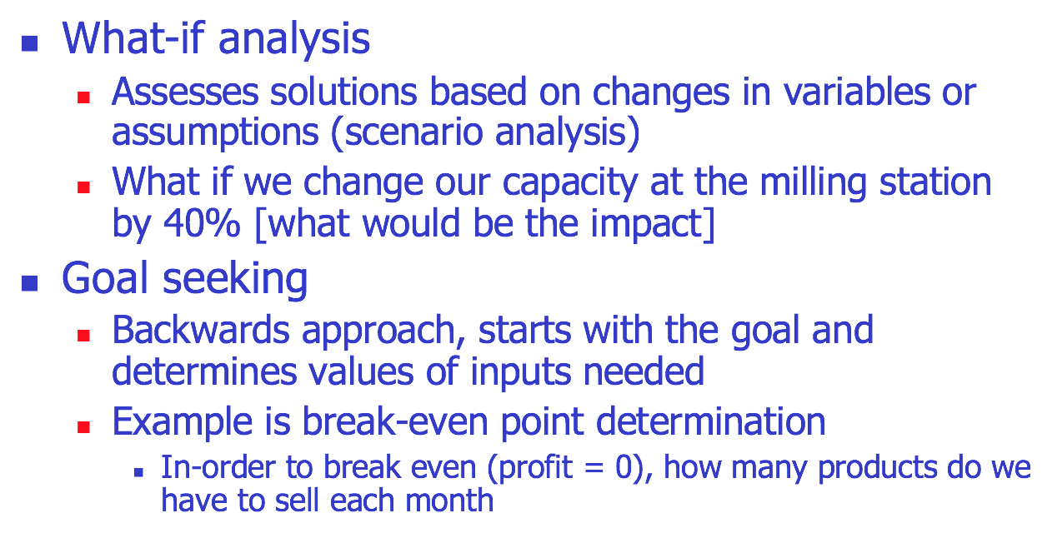

- Define NLP? What its challenges? (Chapter 7)

NLP is …
a very important concept in text mining
a subfield of artificial intelligence and computational linguistics
the studies of "understanding" the natural human language

Challenges in NLP
    - Part-of-speech tagging
    - Text segmentation
    - Word sense disambiguation
    - Syntax ambiguity
    - Imperfect or irregular input
    - Speech acts

- فيه سؤال ما اذكره عن ETL. ^{(Chapter 3)}

